1. Domain name : **INDIAN INSTITUTE OF SCIENCE EDUCATION AND RESEARCH TIRUPATI**

Command : ping iisertirupati.ac.in

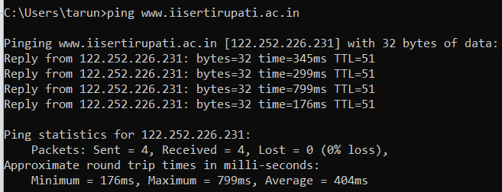

What is my Ip

Ip address : 122.252.226.231

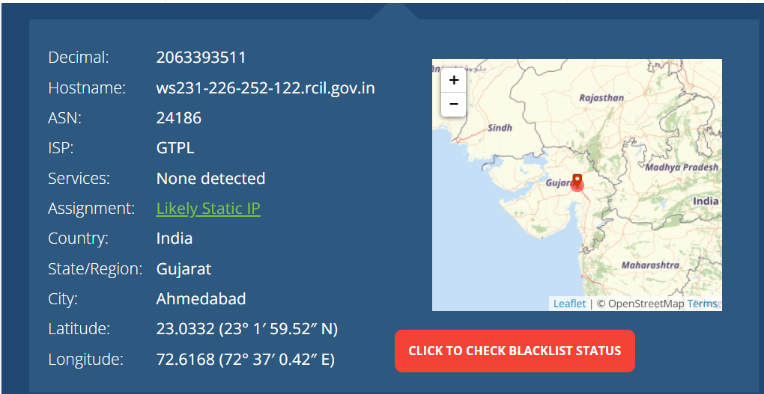

Tracert command : www.iisertirupati.ac.in

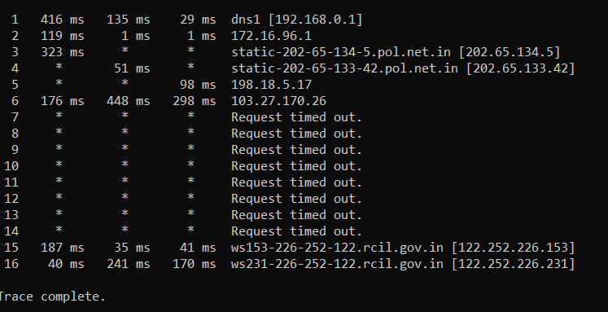

Tracert : hyderabad telangana >hyderabad telangana >not detected > maharashtra mumbai

Ip address : 202.65.134.5

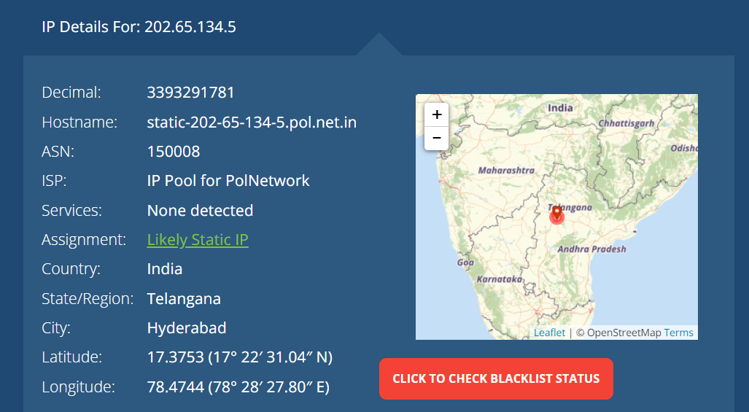

Ip address : 202.65.133.42

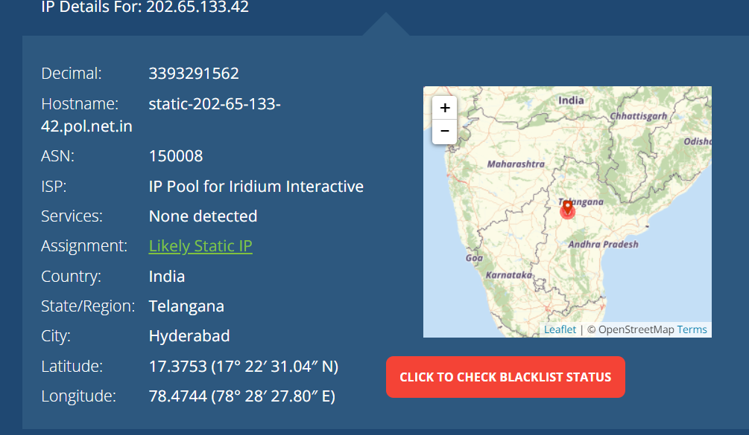

Ip address : 198.18.5.17

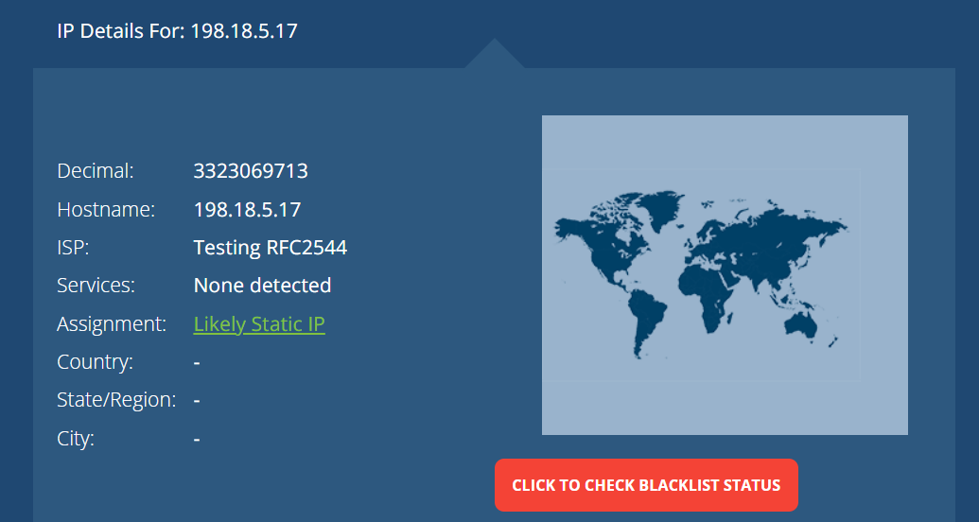

Ip address : 103.27.170.26

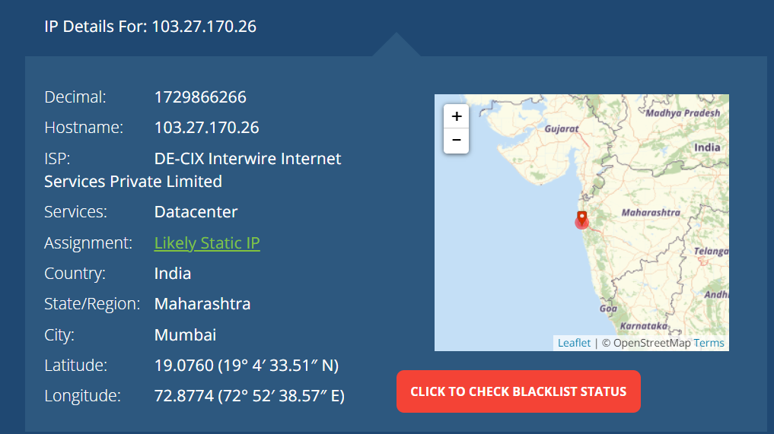

Shodan findings : **INDIAN INSTITUTE OF SCIENCE EDUCATION AND RESEARCH TIRUPATI**

**<https://www.iisertirupati.ac.in/**

[**https://www.shodan.io/host/122.252.226.231**](https://www.shodan.io/host/122.252.226.231)

<https://www.shodan.io/search?query=https%3A%2F%2Fwww.iisertirupati.ac.in%2F>

Ip address : 122.252.226.231

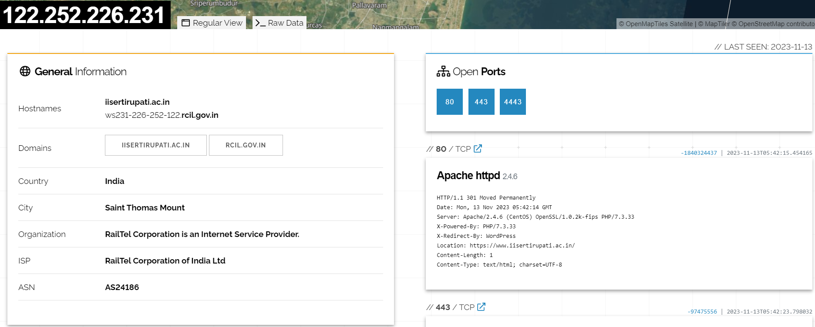

<https://www.iisertirupati.ac.in/>



DNSENUM :

Command : dnsenum iisertirupati.ac.in

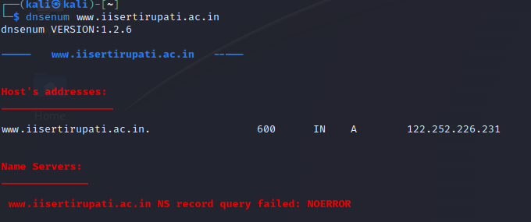

Enum4Linux

Command : enum4linux iisertirupati.ac.in

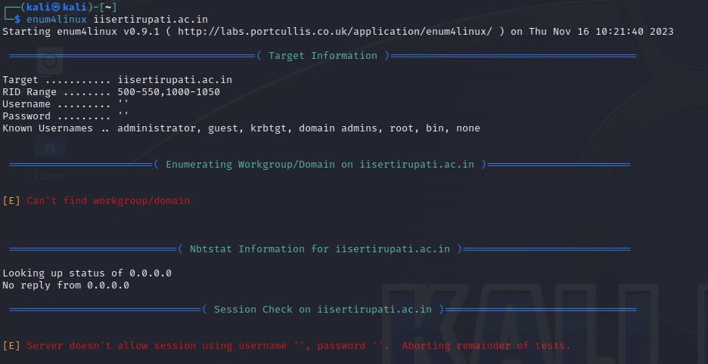

DNSRECON

Command : dnsrecon -d iisertirupati.ac.in

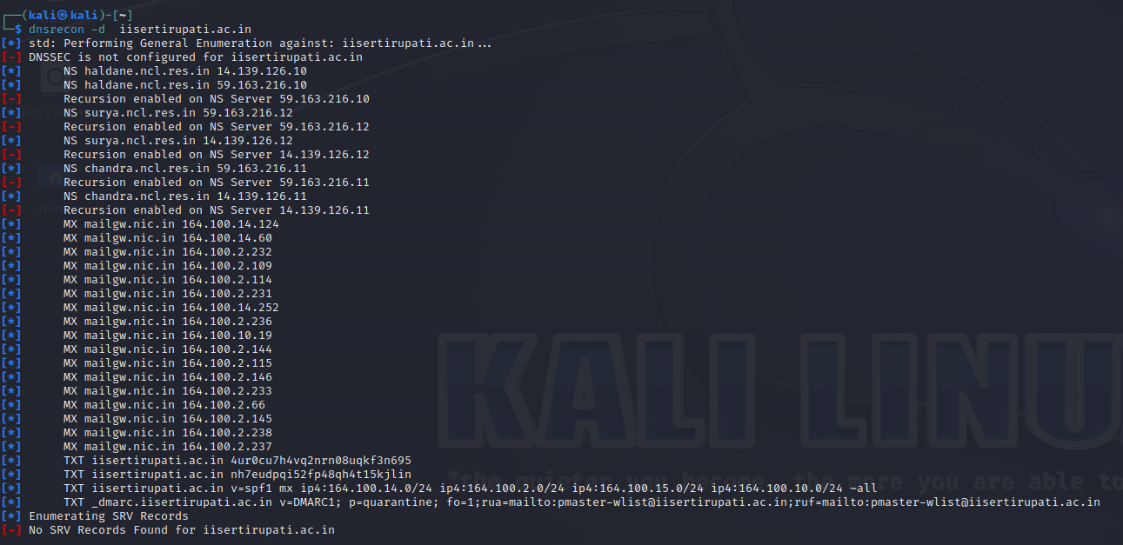

ADVANCE IP SCANNER

IP Address : 122.252.226.231

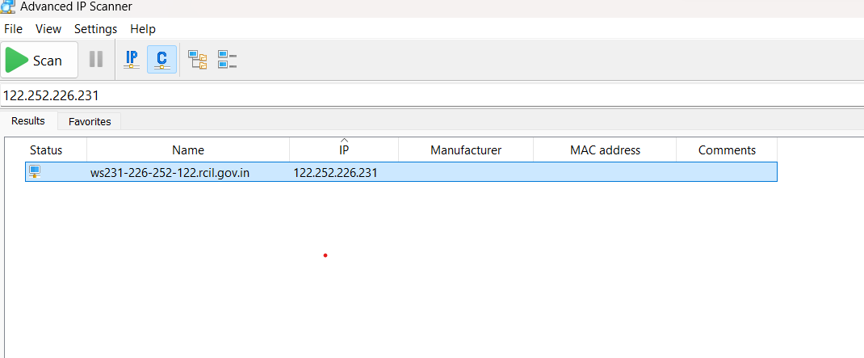

NMAP

Command : 122.252.226.231

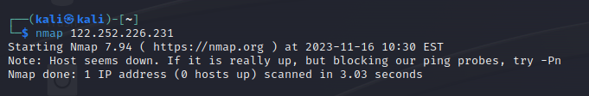

Command : sudo nmap -o 122.252.226.231

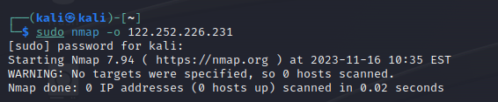.

Command : sudo nmap -sF -sV -VV -Pn 122.252.226.231

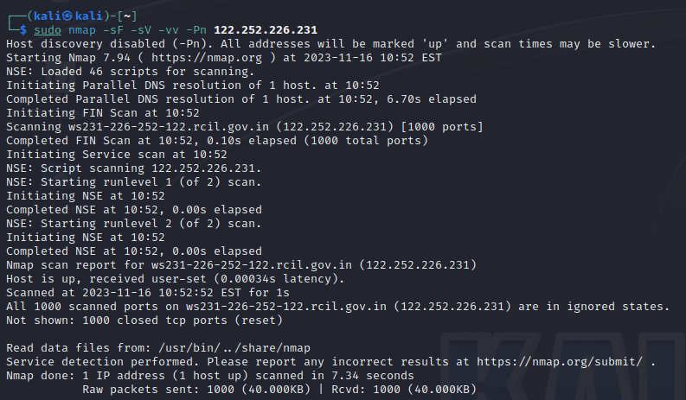

Command : sudo nmap 122.252.226.231 -sA –Pn -vv

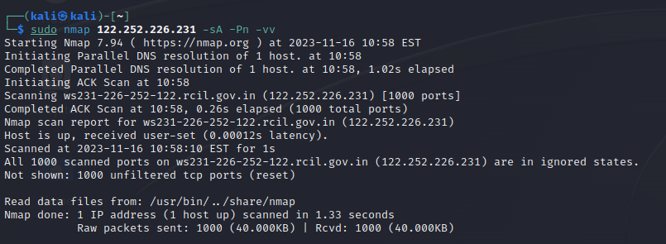

Command : nmap 122.252.226.231 -sA -A -sT -Pn

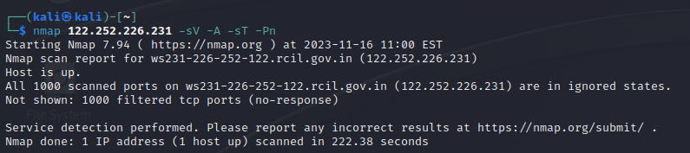

Command : sudo nmap 122.252.226.231 -sV -A -sF -Pn

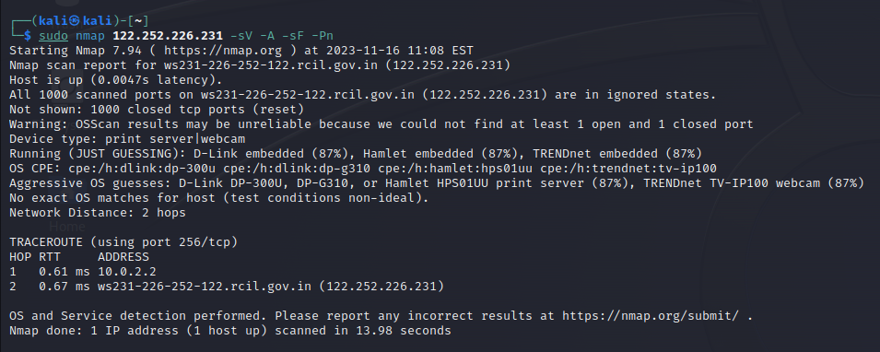

Command : sudo nmap 122.252.226.231 -sV -A -sA -Pn

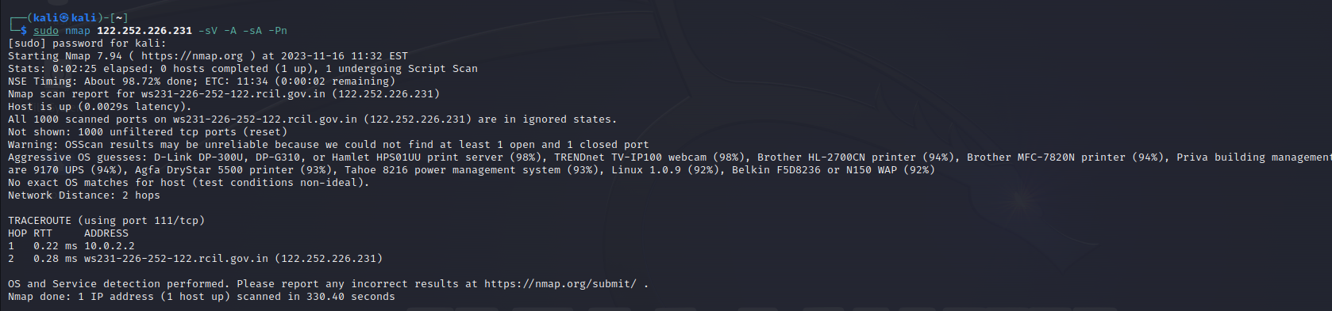

NMAP SCRIPTS

Command : sudo nmap 122.252.226.231 -sV -Pn --script=discovery

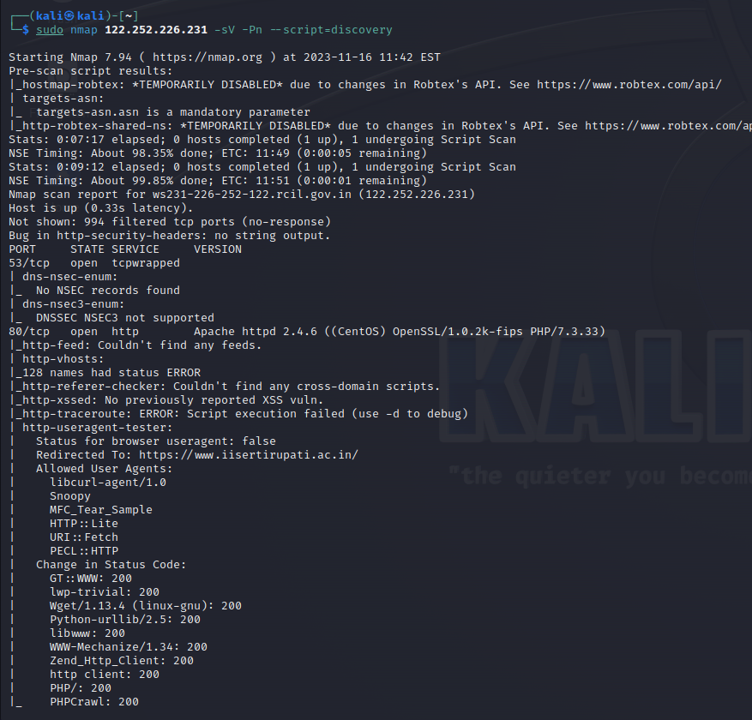

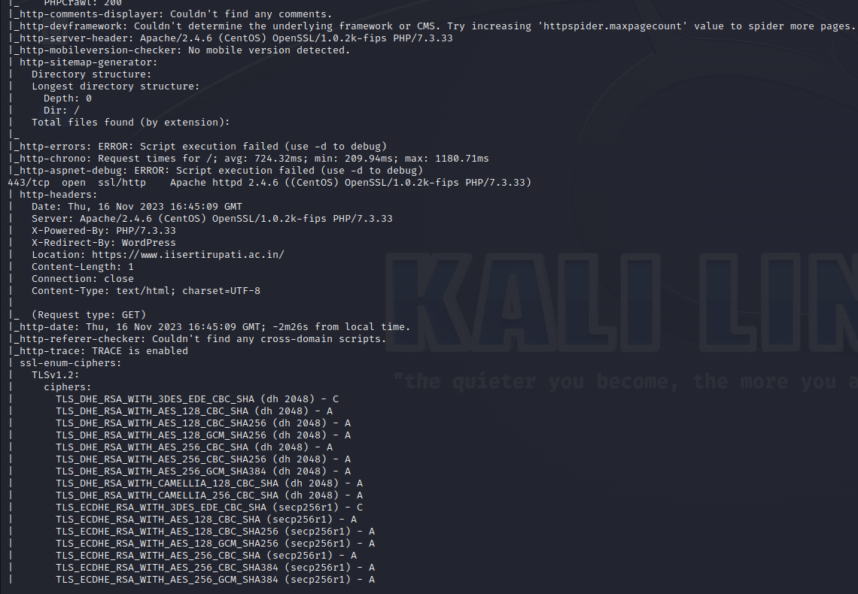

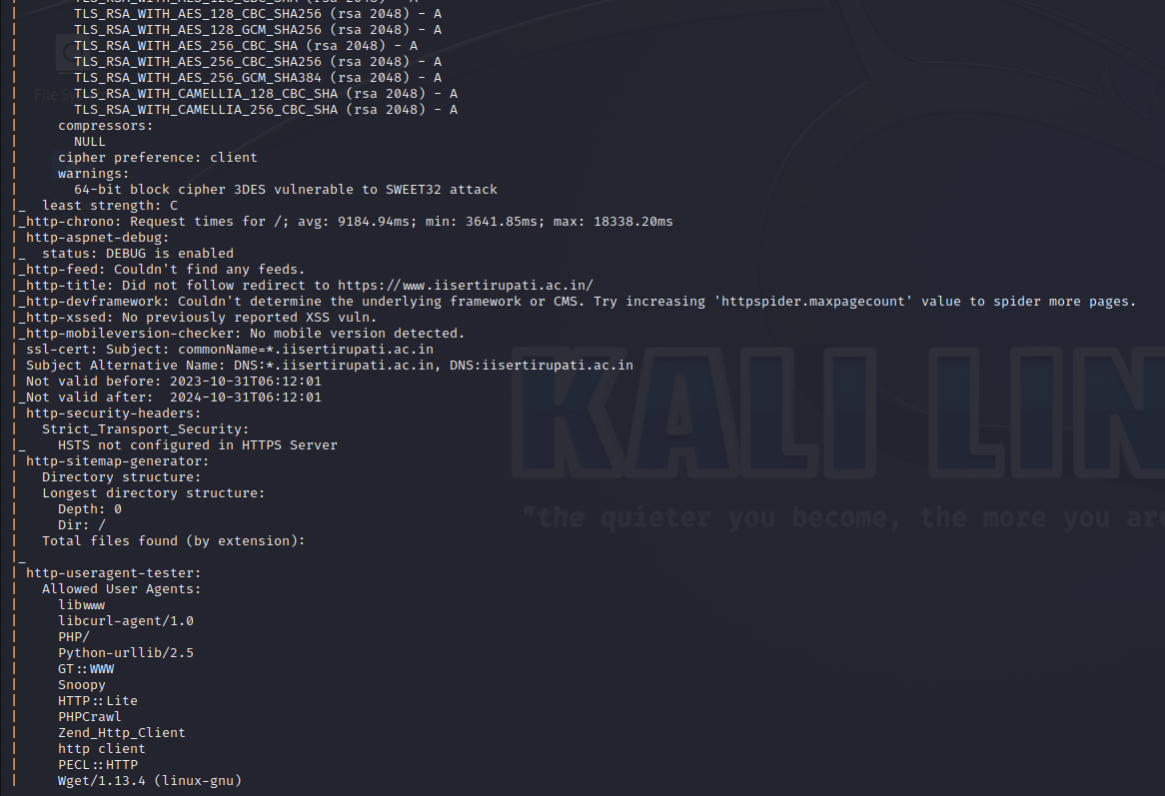

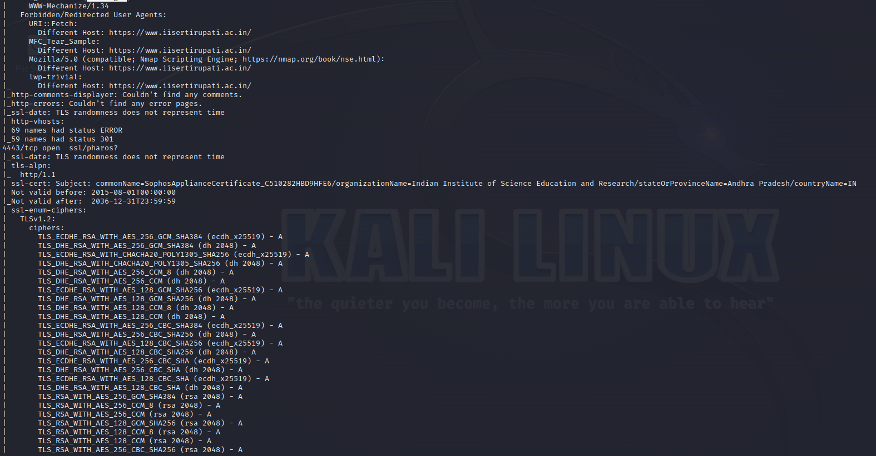

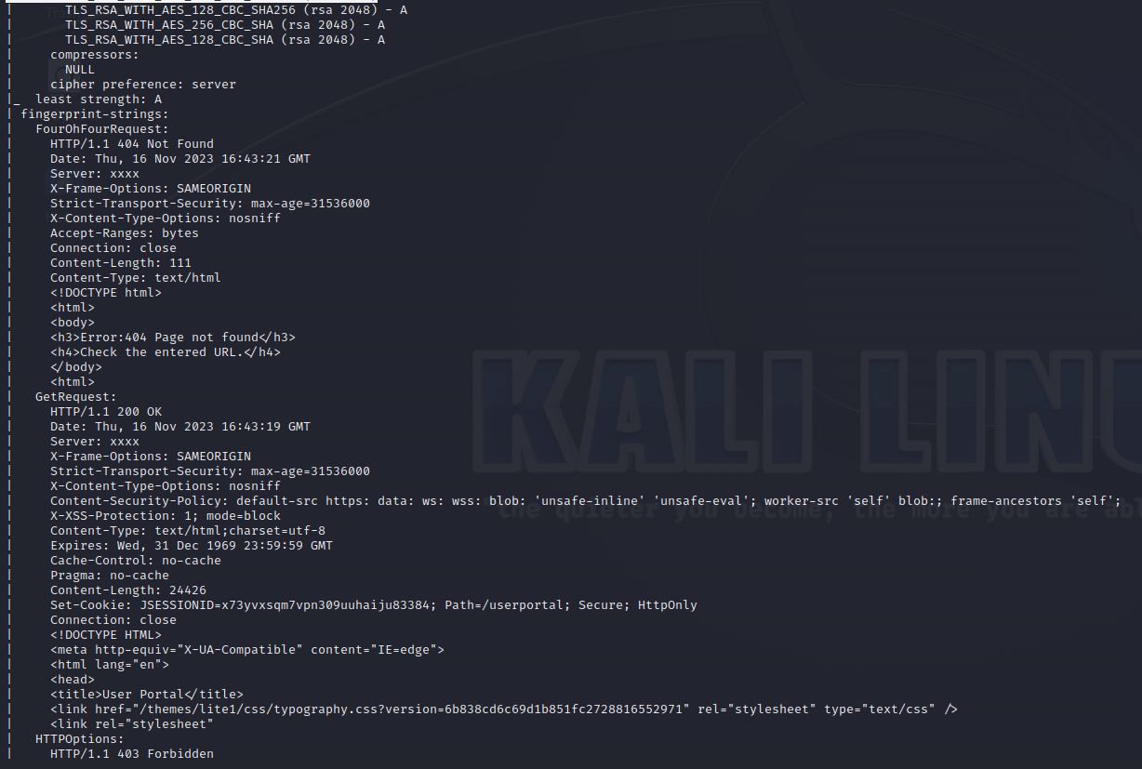

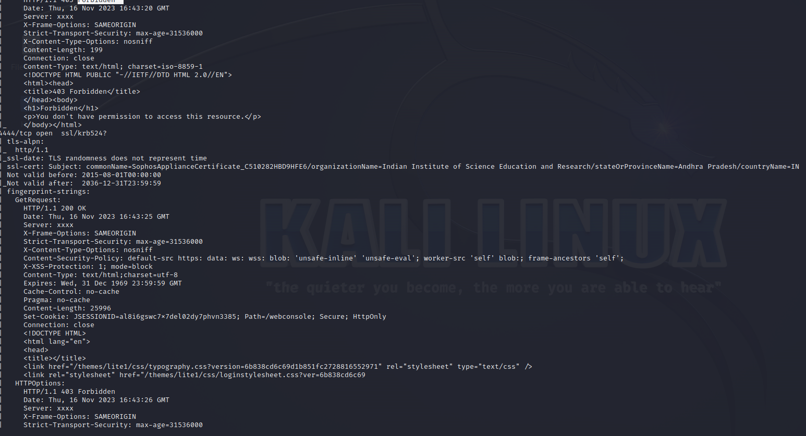

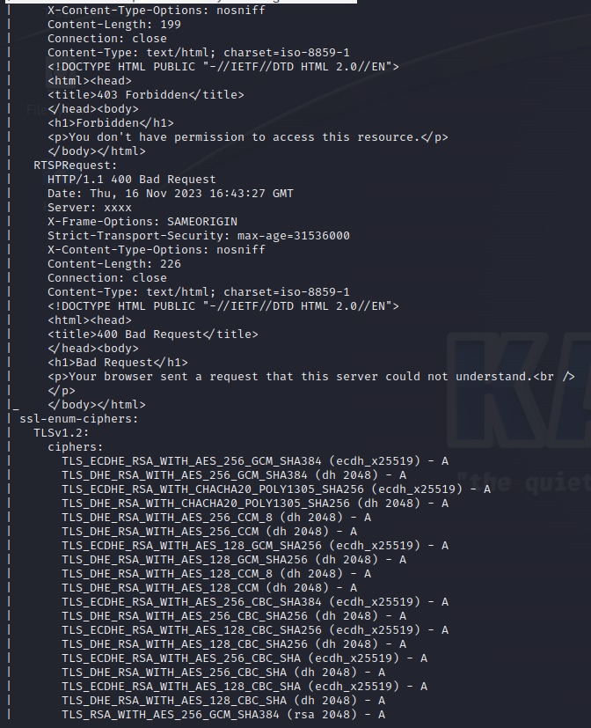

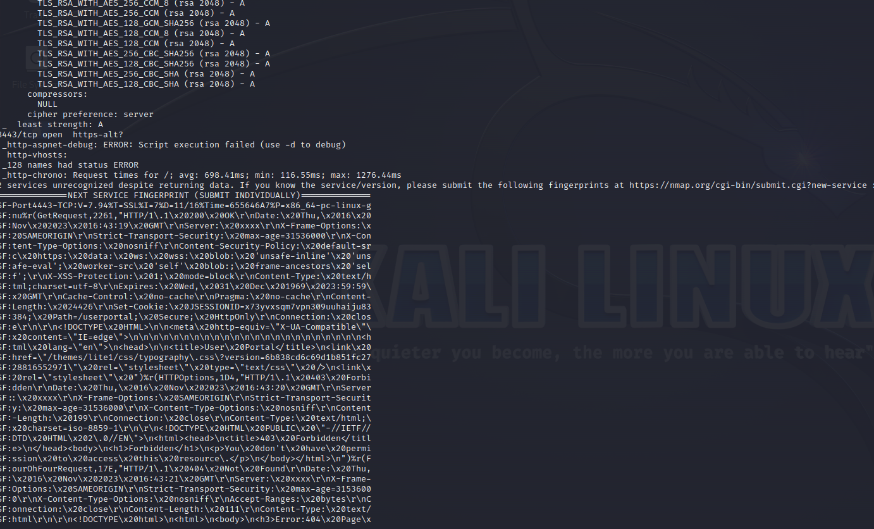

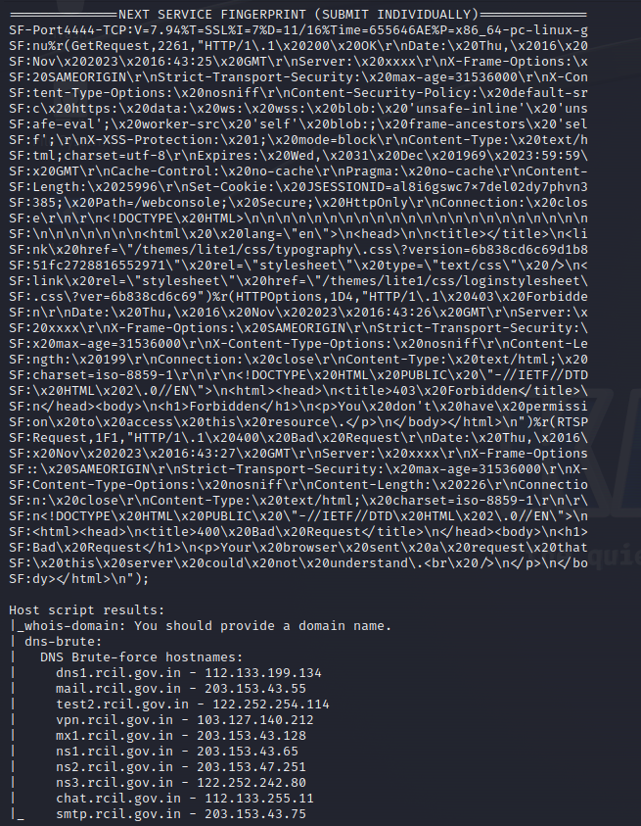

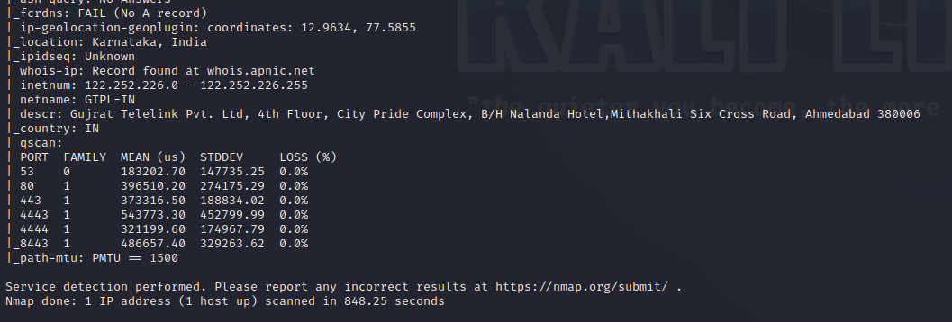

Command : sudo nmap 122.252.226.231 -sV -Pn --script=default

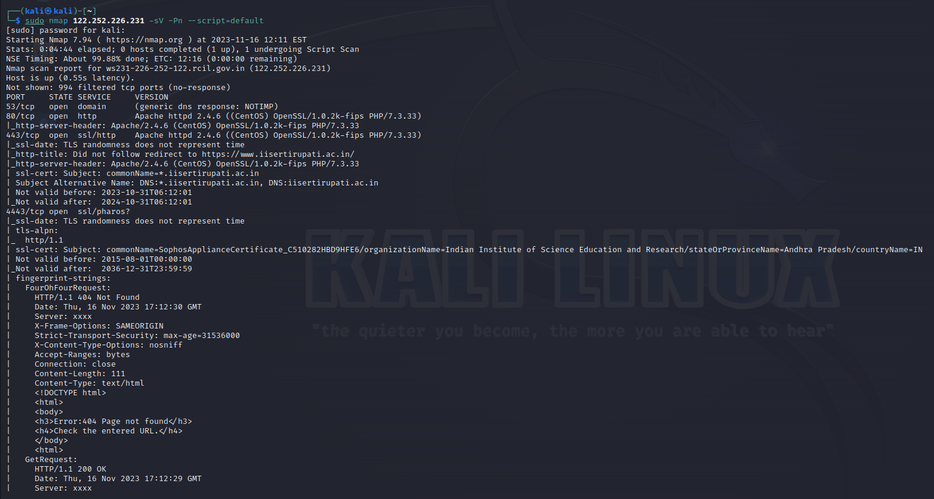

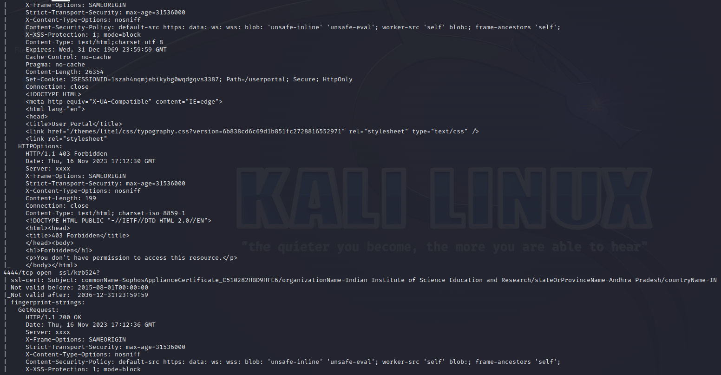

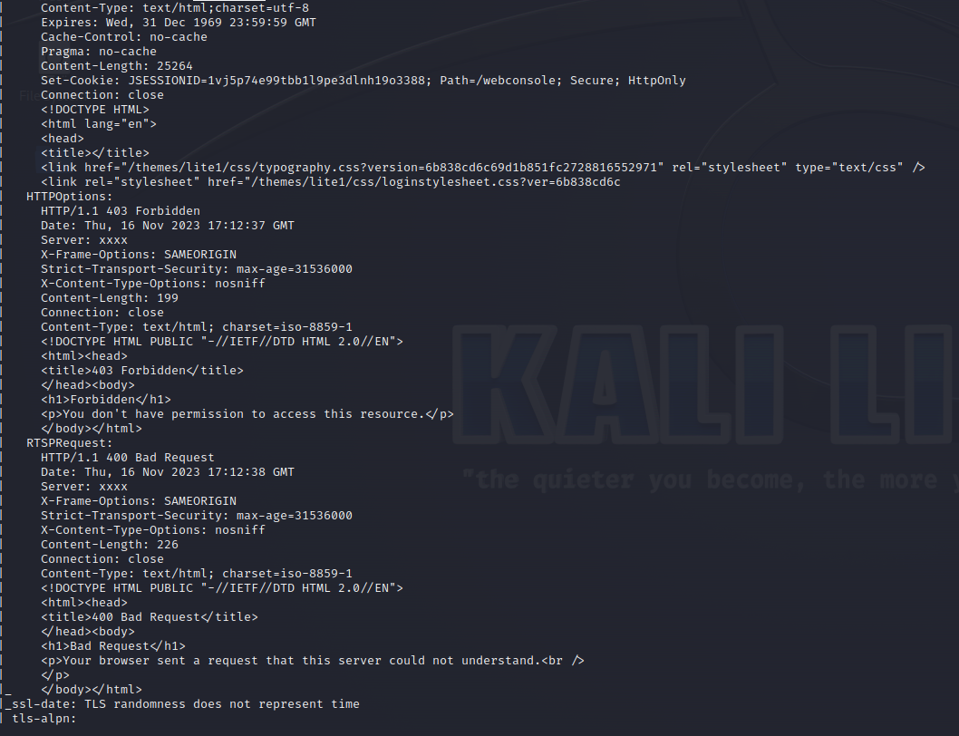

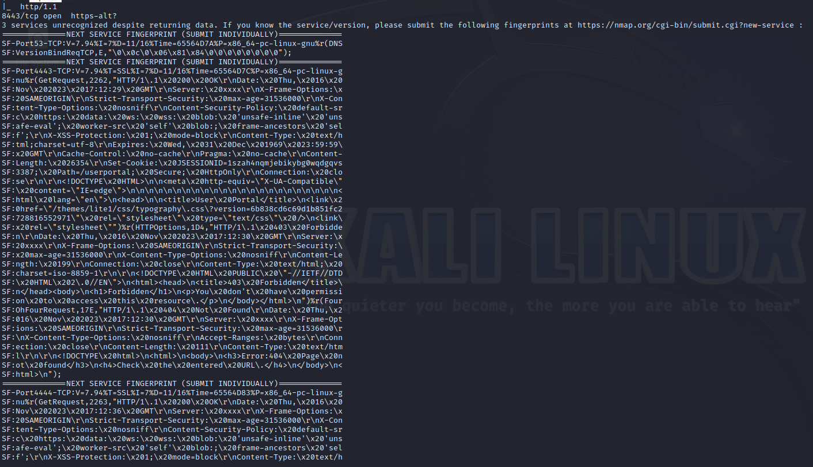

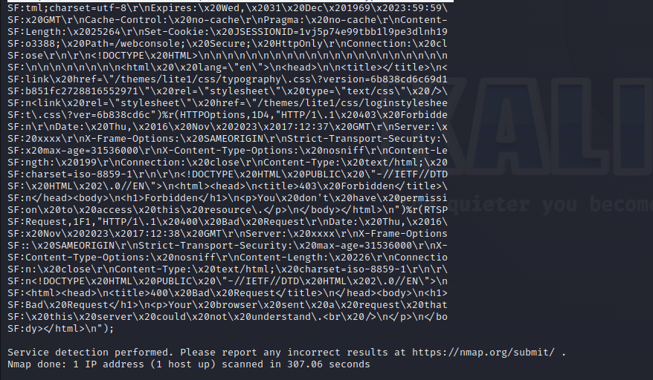

**Command :** sudo nmap 202.70.90.4 -sV -Pn --script=vuln

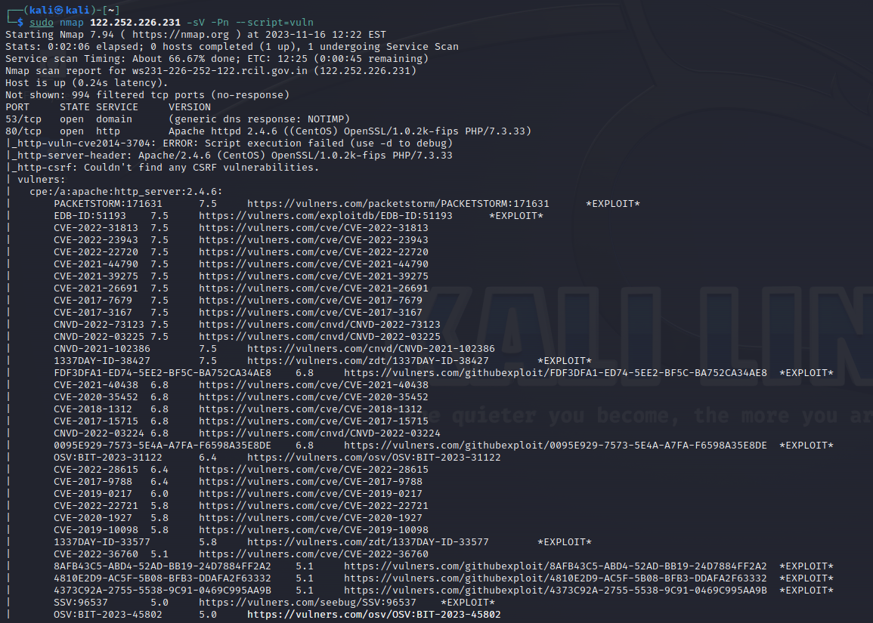

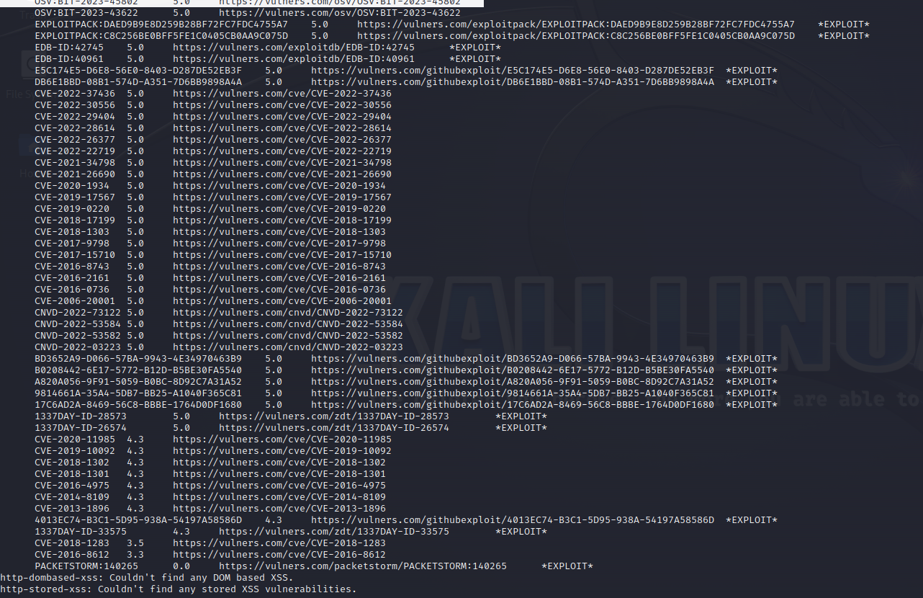

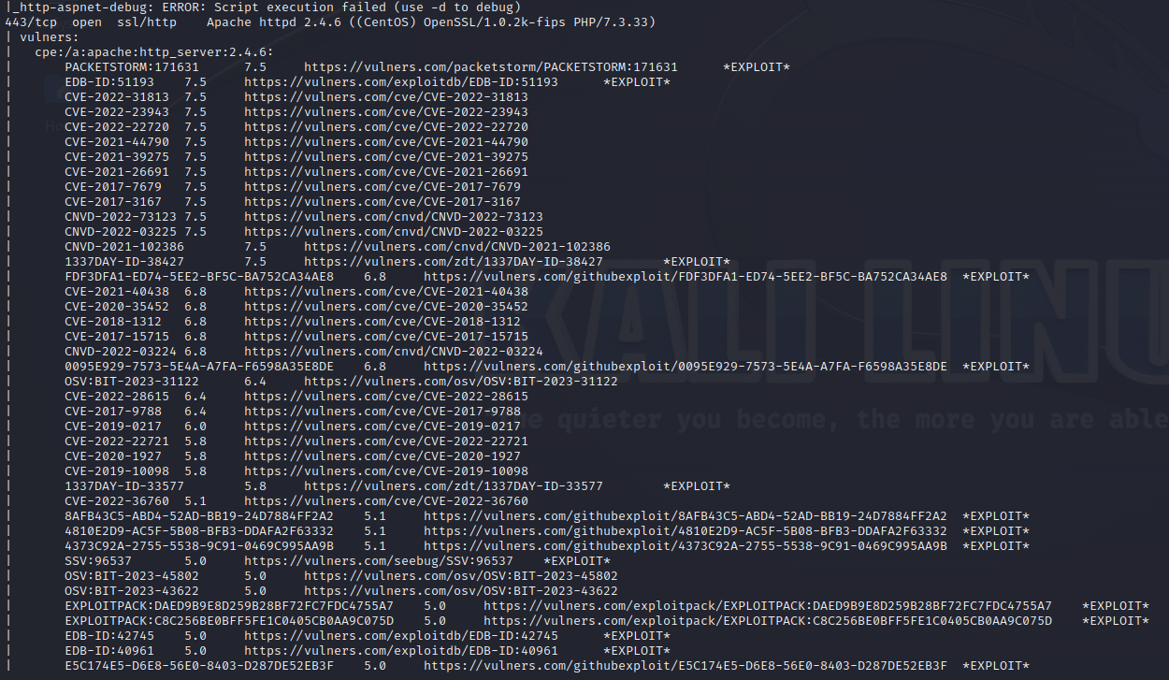

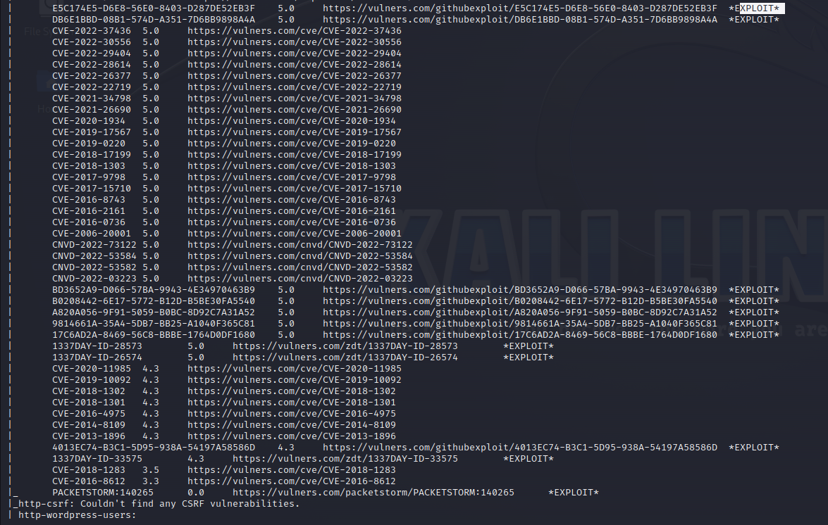

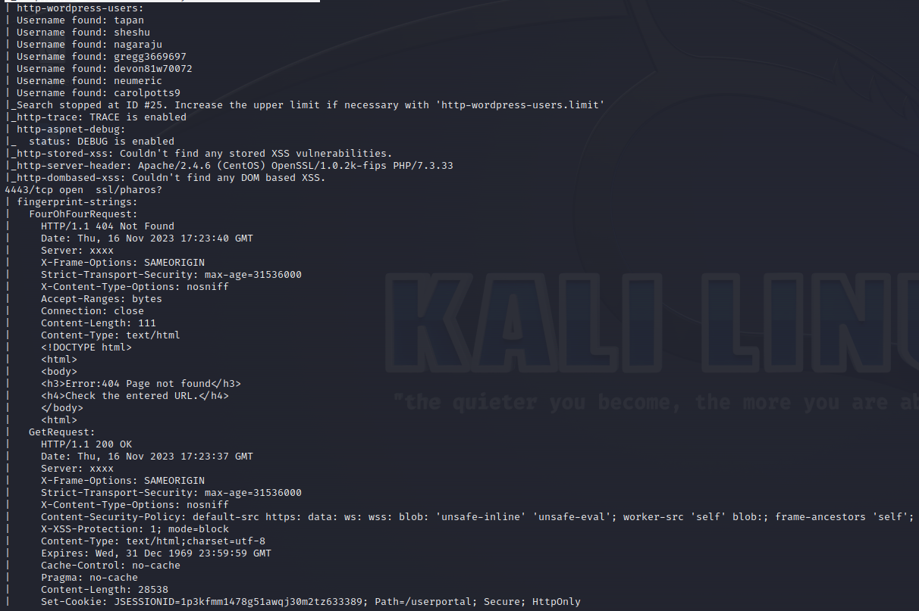

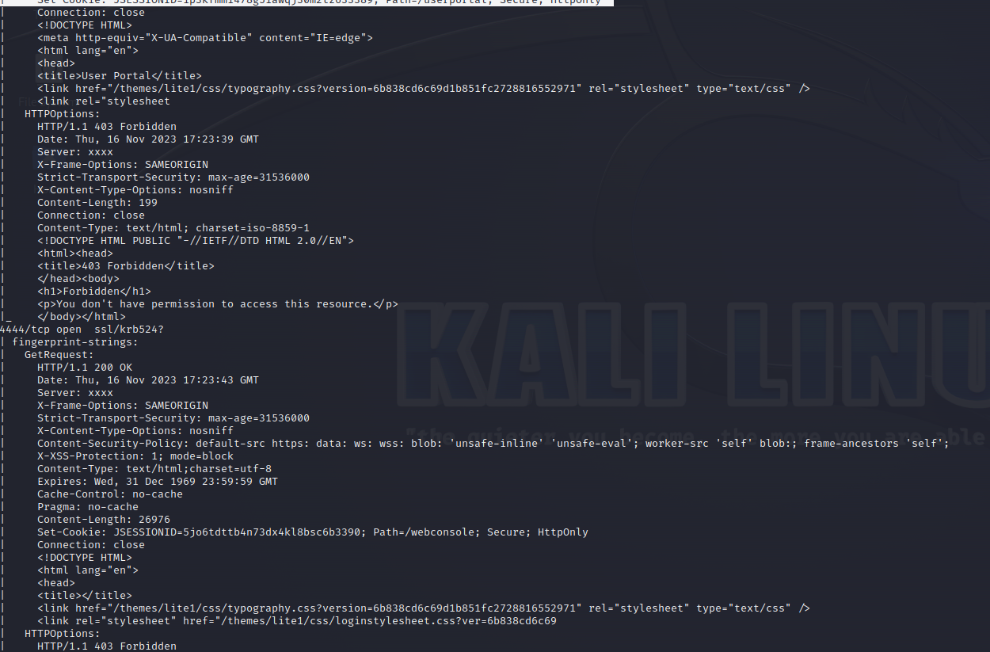

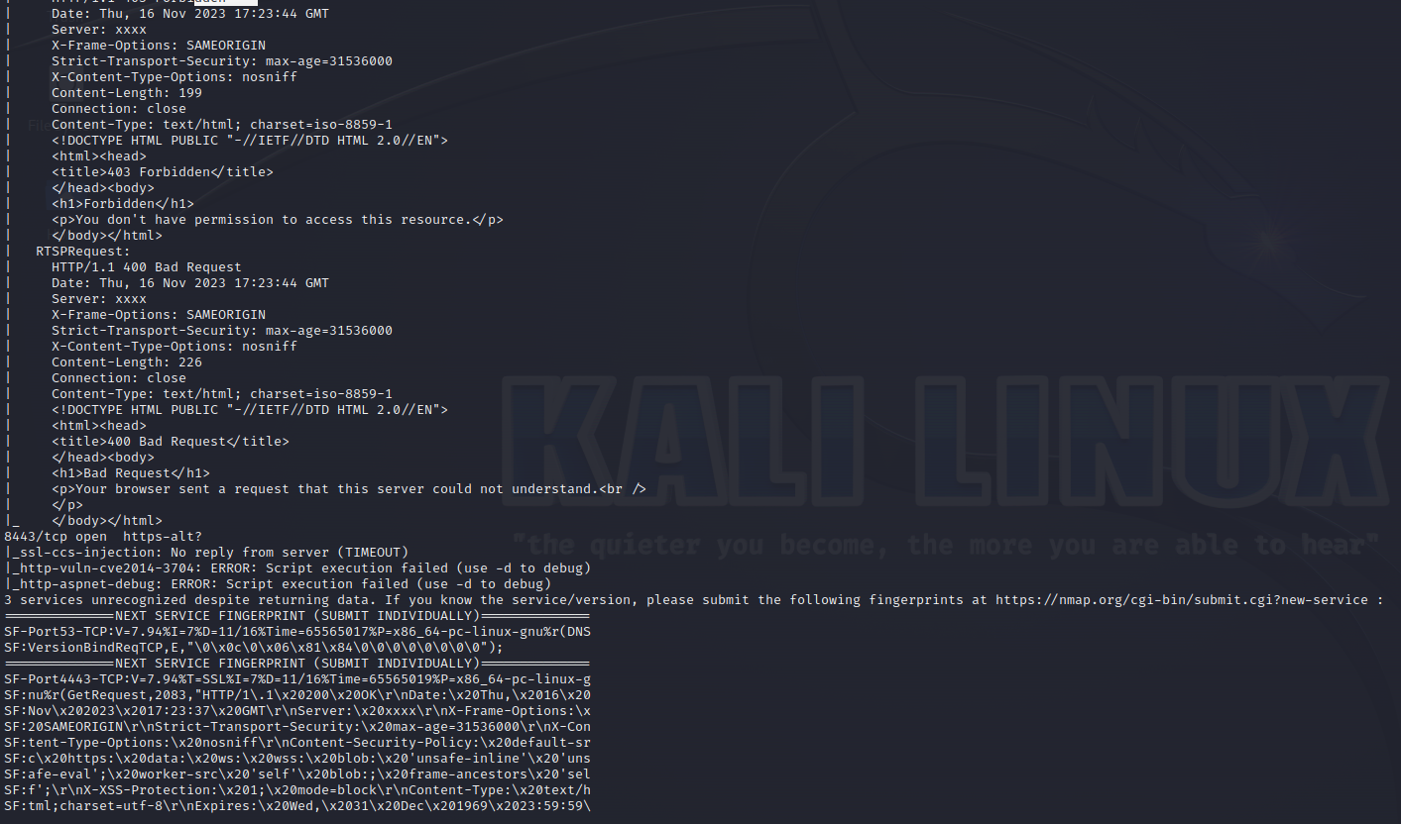

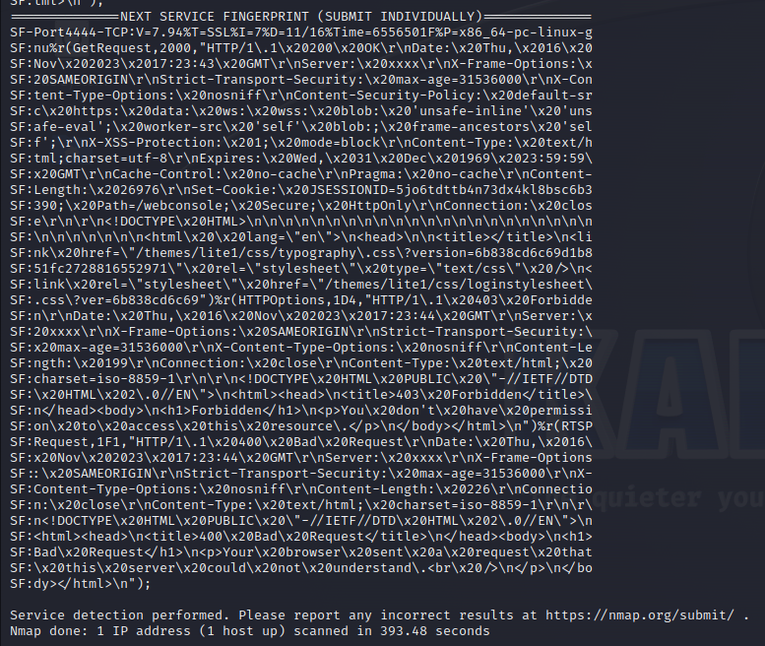

Command : sudo nmap 202.70.90.4 -sC -sT -Pn --vv -sV --script=http*

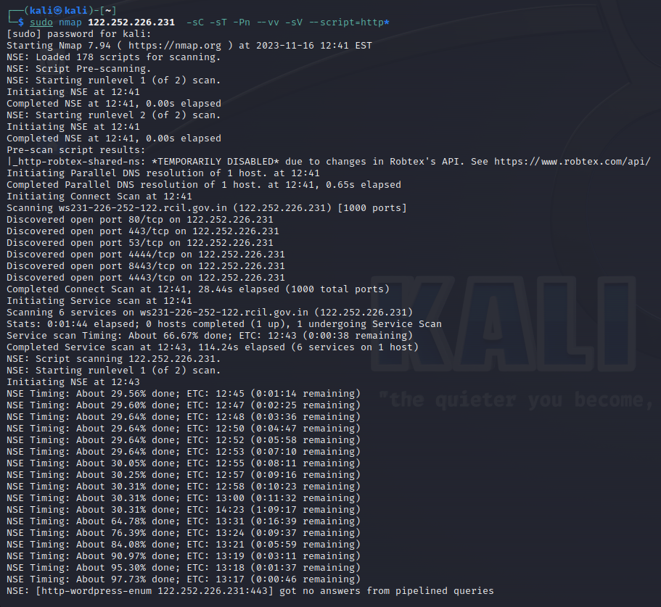

**Command :** nmap --script=http-trace 122.252.226.231

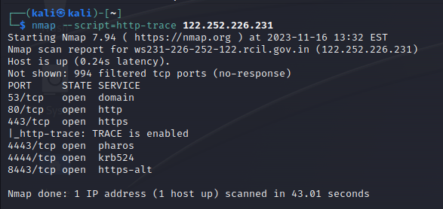

Command : nmap --script=http-vhosts 122.252.226.231

